SoR Fin Fan Cooler Analysis Tool – User Guide
- Ensure that the workspace folder has the application accompanied by the excel files, this pdf, etc. similar to the view below:
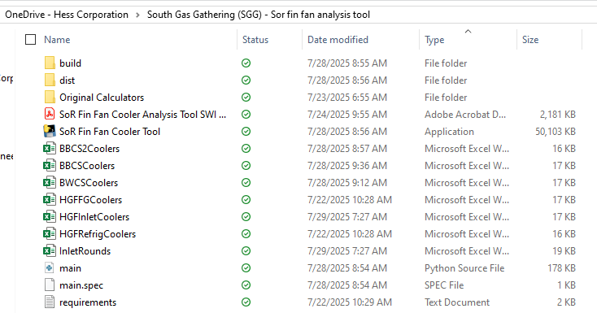
- Next, access the application titled ‘SoR Fin Fan Cooler Tool.exe’. This should be the view:
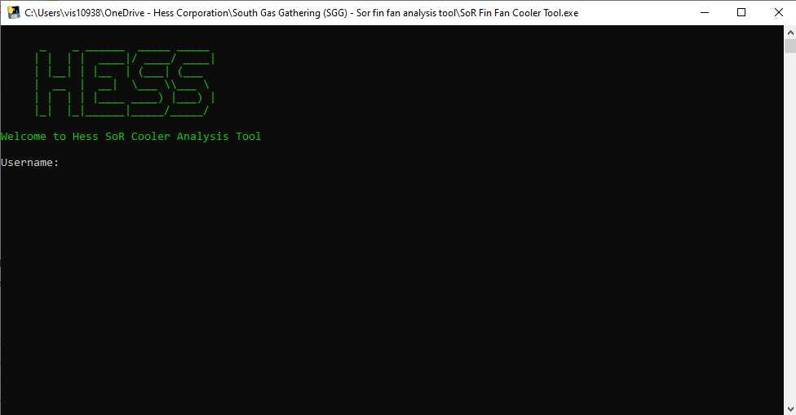
- Input Hess credentials (Username: first.m.last@hess.com)
- Next, you will be prompted to enter a cooler type at a facility:
‘HGF’ for Hawkeye
‘BBCS2’ for Blue Buttes 2
‘BWCS’ for Buffalo Wallow
‘BBCS’ for Legacy BB
- If BBCS2 or BWCS selected, follow prompts to save the generated analysis (fully automated)
If HGF or Legacy BB selected, follow additional steps below for exporting Operator Rounds data, required for computation
- Saving Plots: plots must be manually saved (click the save icon at the bottom right of the plot window):
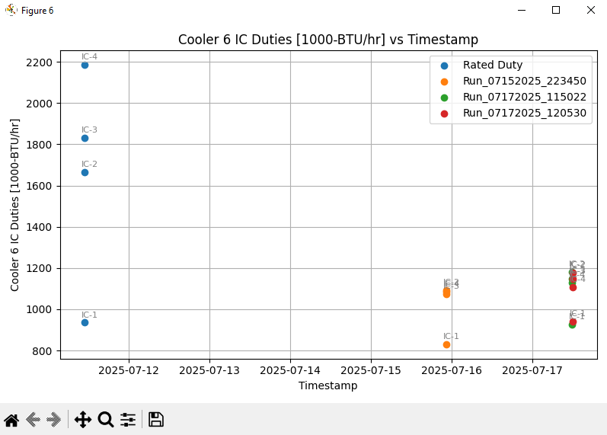
- If you forget to save a plot, open the workbook and delete the most recent run sheet, then re-run the program and re-submit pertinent parameters
AS OF 07/29/2025,
- BWCS 1-4 PI TAGS ARE INSERTED WITHIN PROGRAM—AWAITING DATA FROM TRANSMITTERS
- HGF FG 2&3 UNAVAILABLE
- HGF REFRIG 2 UNAVAILABLE

SoR Fin Fan Cooler Analysis Tool – Notes and Reminders
- Excel workbook name must be exact (case sensitive) and in the same folder as application
- There are 6 presently:
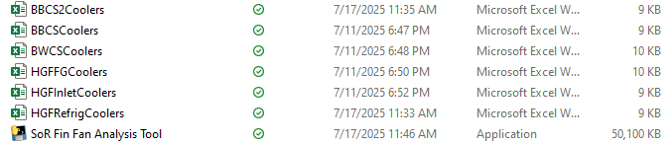
- (If using Operator Rounds from Webview AMS – Required for HGF and Legacy BB) Access compressor discharge temps by connecting to Webview AMS at https://www.webviewams.com/planning.aspx. Here, you must export the Responses view.
- (If using Operator Rounds from Webview AMS – Required for HGF and Legacy BB) Once logged in, from Planning, go to a date and select ‘DONE’ Select a unit ‘Responses’:
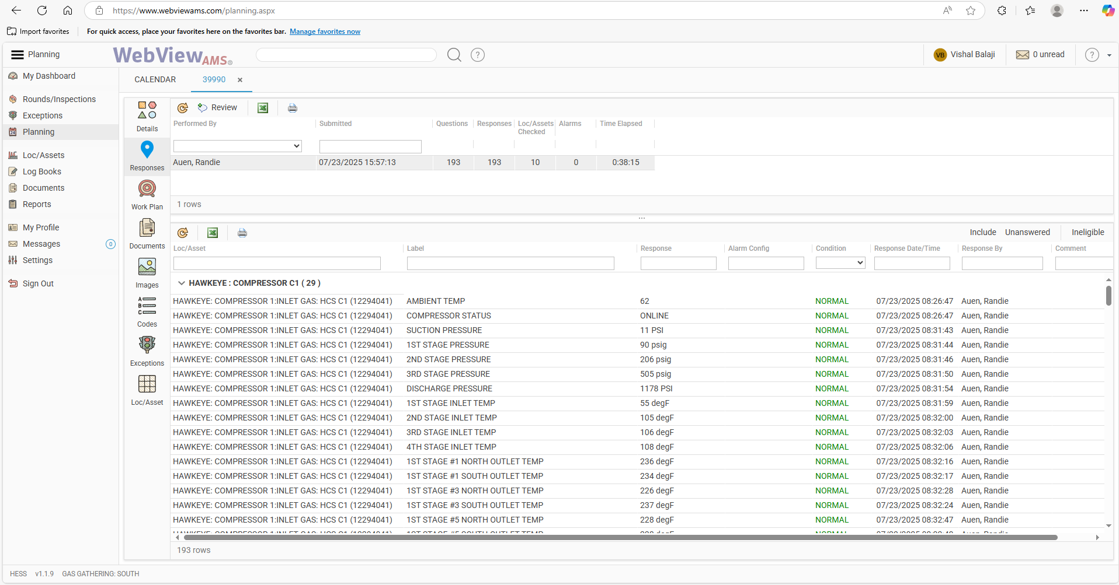
- (If using Operator Rounds from Webview AMS – Required for HGF and Legacy BB) Here, press the Excel sheet button located in the top left:

- (If using Operator Rounds from Webview AMS – Required for HGF) Once the sheet is downloaded, move it to the main folder along with the other sheets, and rename it according to how you are prompted to name it upon running the program:
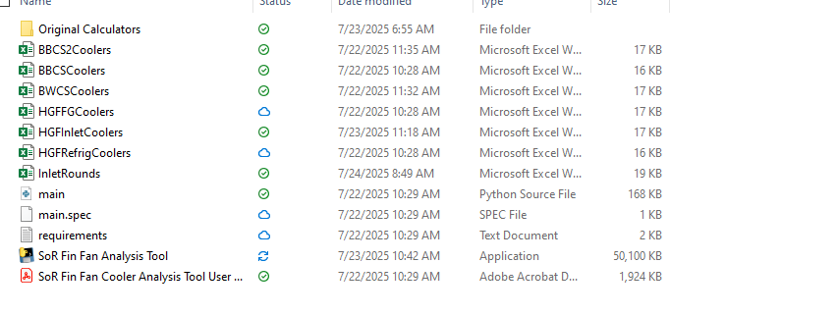
Now, continue using the program as usual to obtain duties for these coolers
**NOTE: Program does not work if any units are not running that are not normally running (not compatible with ‘OOS’ or ‘STANDBY’ for a unit that is usually on)
- Understanding the excel sheet:
- Whenever a run is executed, data is pulled and stored in one of the aforementioned excel workbooks as a new sheet:
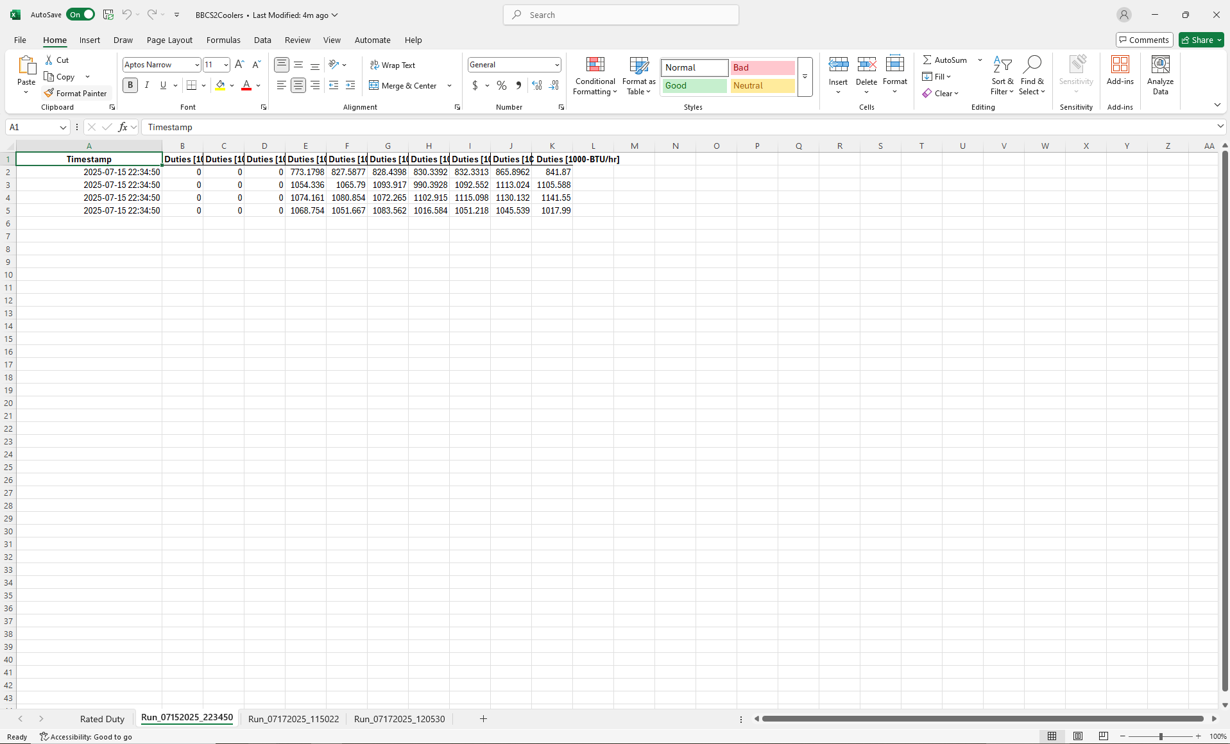
The arrow points to the sheet and timestamp obtained for a single run, taken on 07/15/2025 at 22:34:50

- Within a single run sheet, the first column indicates the timestamp of the data pull, followed by columns for each cooler. Each of the rows is designated for each stage of cooling (e.g. IC-1, IC-2, EJW, etc.):

Cooler #
Stage-#
For instance, the upper leftmost duty is for Cooler 1, IC-1. Below it is Cooler 1, IC-2, and to the right of it is Cooler 2, IC-1

SoR Fin Fan Cooler Analysis Tool – Adding Units for Analysis for BWCS
- Open python program in VS Code (free download at https://code.visualstudio.com/)
- Next, open the application and select ‘Open Folder’:
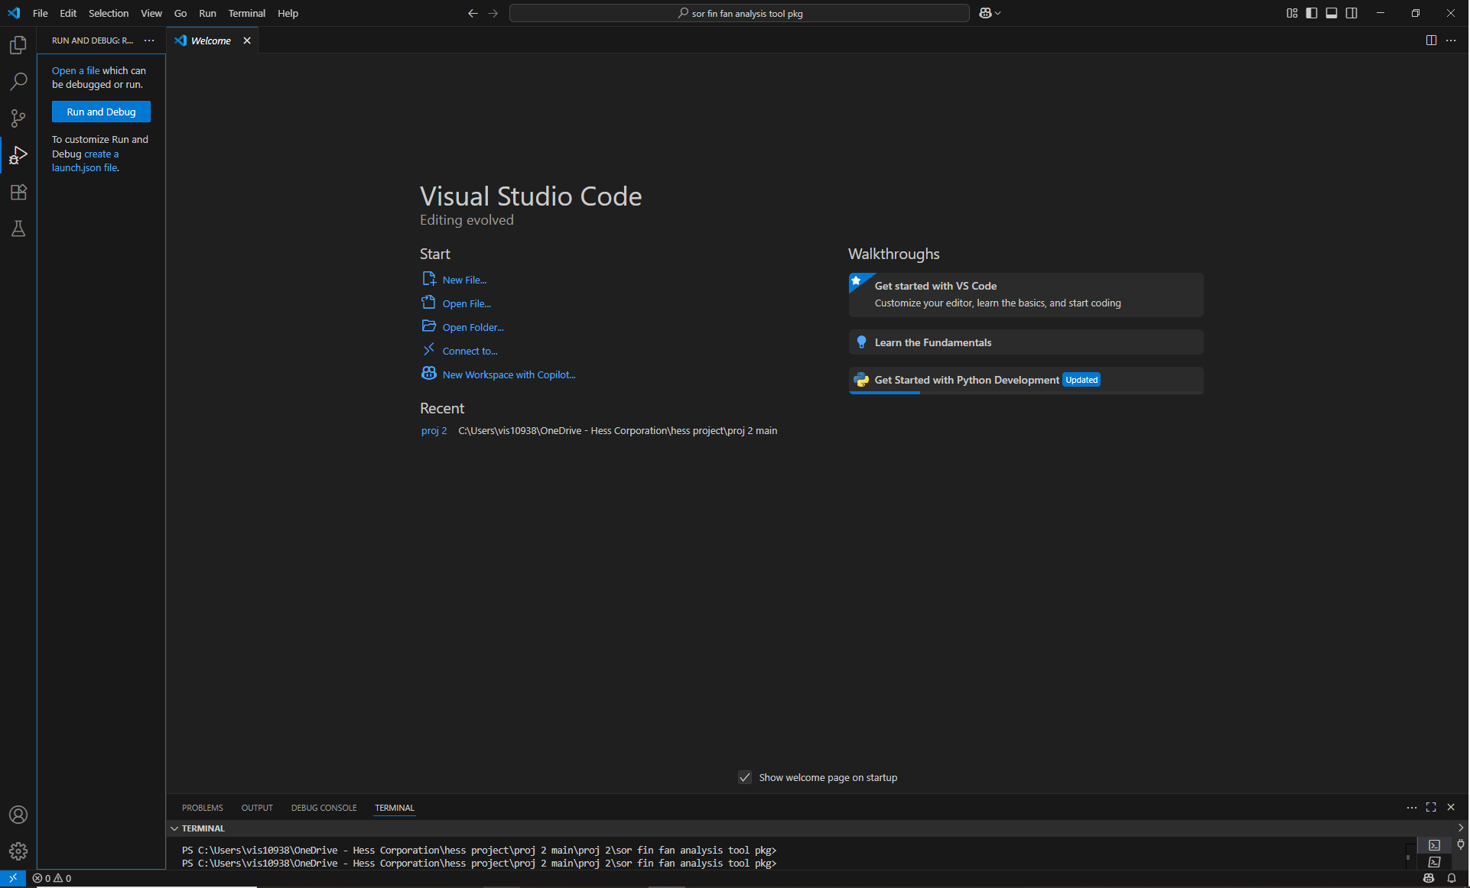
Find the project folder containing the .py file (and all the excel workbooks, etc.)
- Open ‘main.py’:
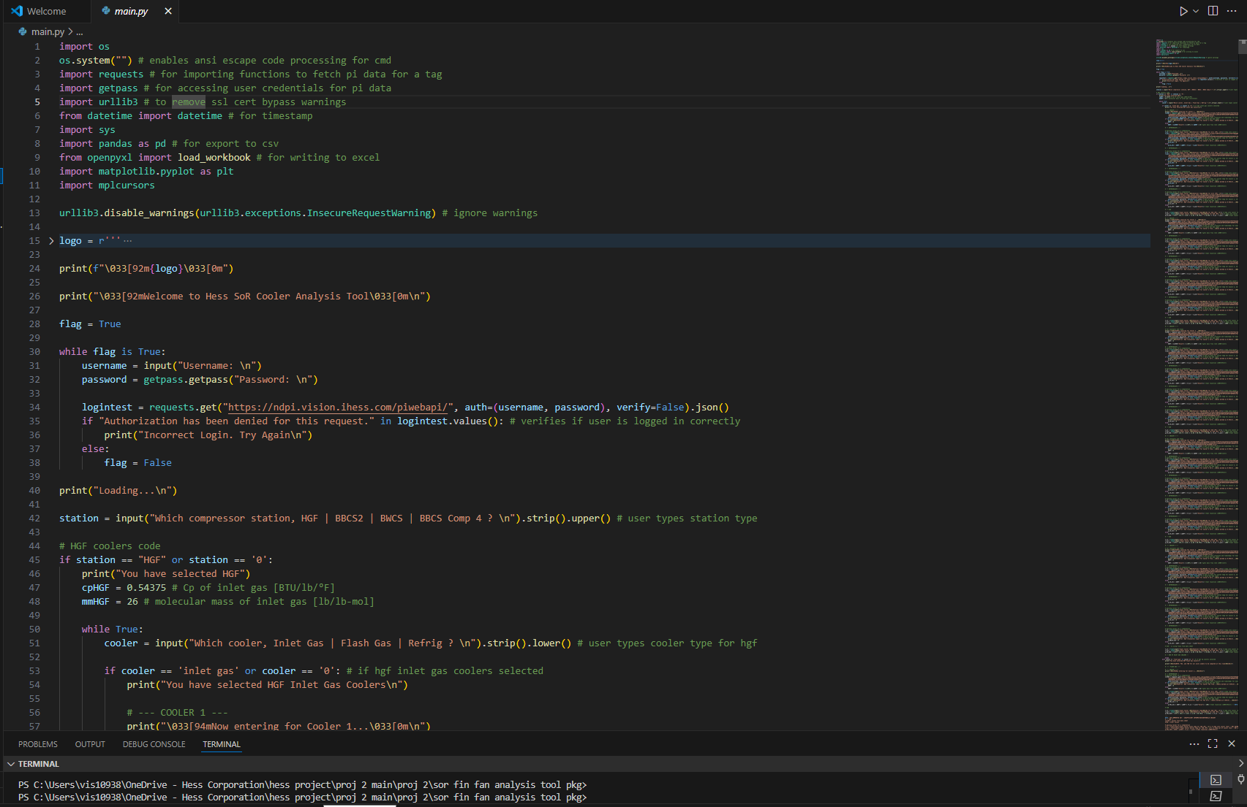
This is what the display will look like. The lower area is the terminal; the upper area is the bulk code. The terminal is where a few measures must be performed before beginning program manipulation.
- In the terminal, execute the following command:
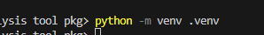
to create a virtual environment. This is necessary to run the dependency packages for various libraries in the code.
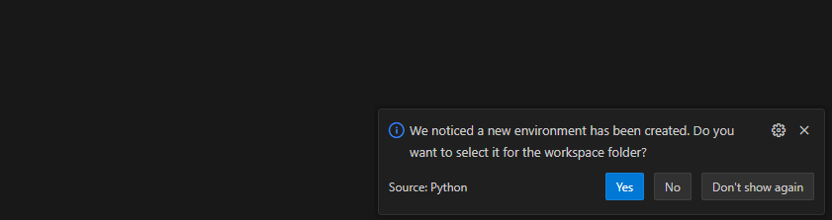
This message will appear in the bottom right corner. Select ‘Yes’
- Next in the terminal, execute the following command:
The second line is what should happen. You have entered the virtual environment to operate and execute the program.
- Finally, install all the dependencies using the following line:
Now, the main.py is in a workable state for further modification, testing, and packaging.
- Now, go to ‘BWCS coolers code’ section:
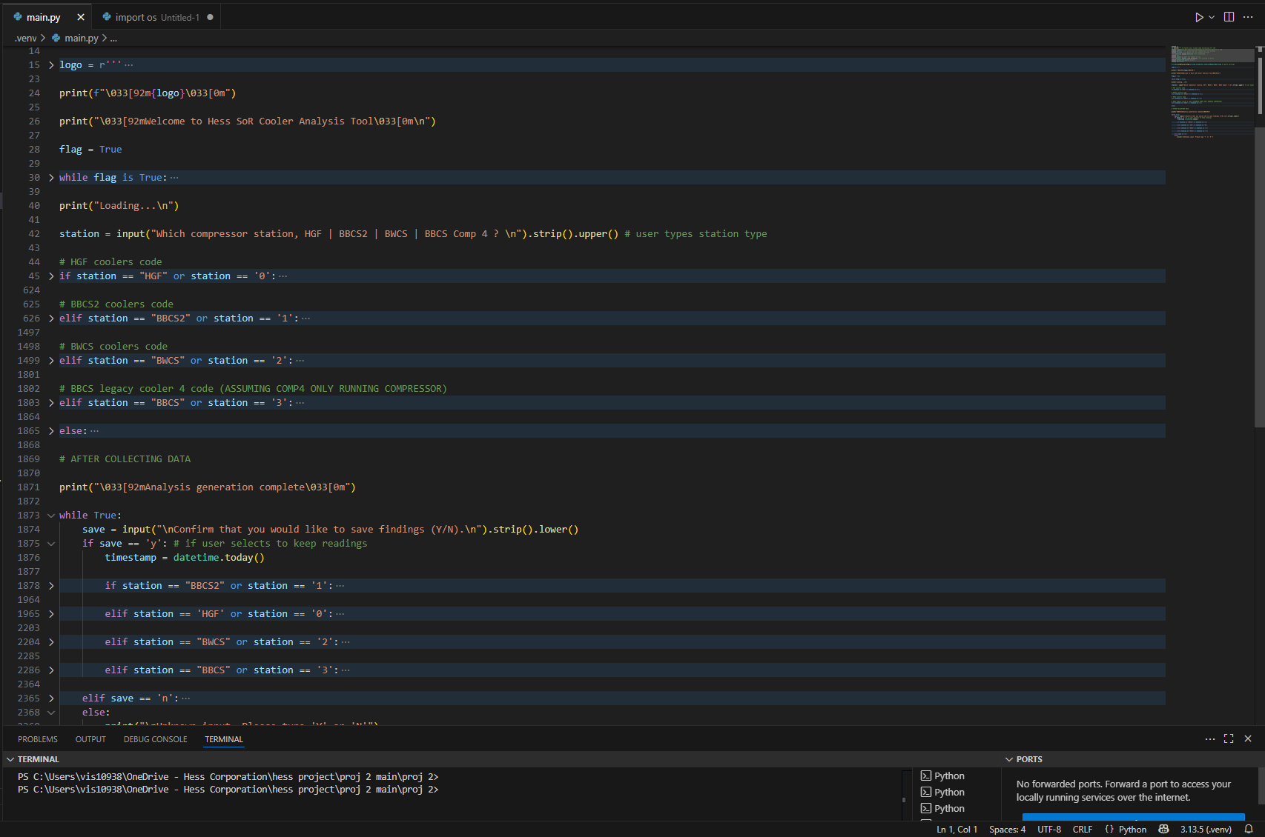
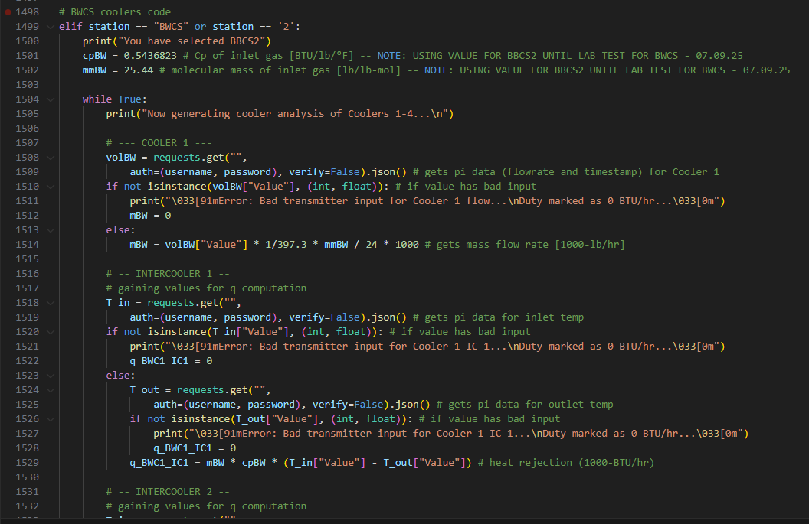
This is where the bulk of the code is pertaining to the automated Pi tag data pull. The arrow points to what must be filled in in order to allow operation for this data automation point.
- Go to Pi Web API at this link: https://ndpi.vision.ihess.com/piwebapi/dataservers/F1DSvVzCIaSjSkCZuCntY8tYTQTkRQSURBQ09MTA/points?maxCount=40000
It will take a few minutes to load. This is a comprehensive list of all the links for our pi tags across ‘NDPIDACOLL’
As you search for the correct Pi WebAPI link in the later sections, this ‘maxCount’ part will prove important—you can increase the amount of items it shows by increasing the number from 40000. This is done if in the initial 40,000 results, the Pi tag cannot be found.
- Press ‘Ctrl + F’ to search the page, and enter the Pi tag to look for its API address. There may be more than one result that it finds—ensure that the link pertains to the correct Pi tag (FIT vs. TIT vs. VIT etc.)
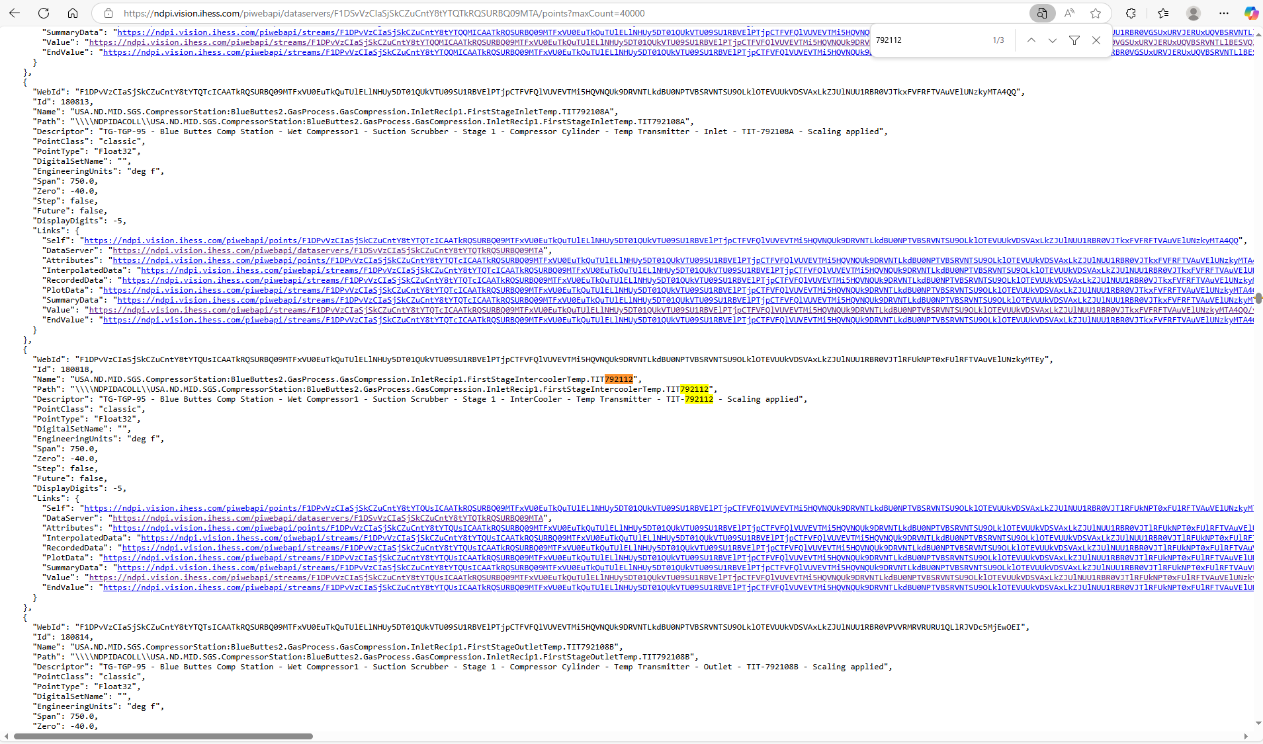
- Once the desired item is found, grab the link listed beside “‘Value’:”. This is your API link that must go back into the program script

Here is a matrix of all relevant Pi tags for BWCS:
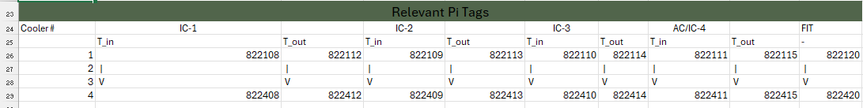
- Copy and paste the link and insert into the script in between the quotations:
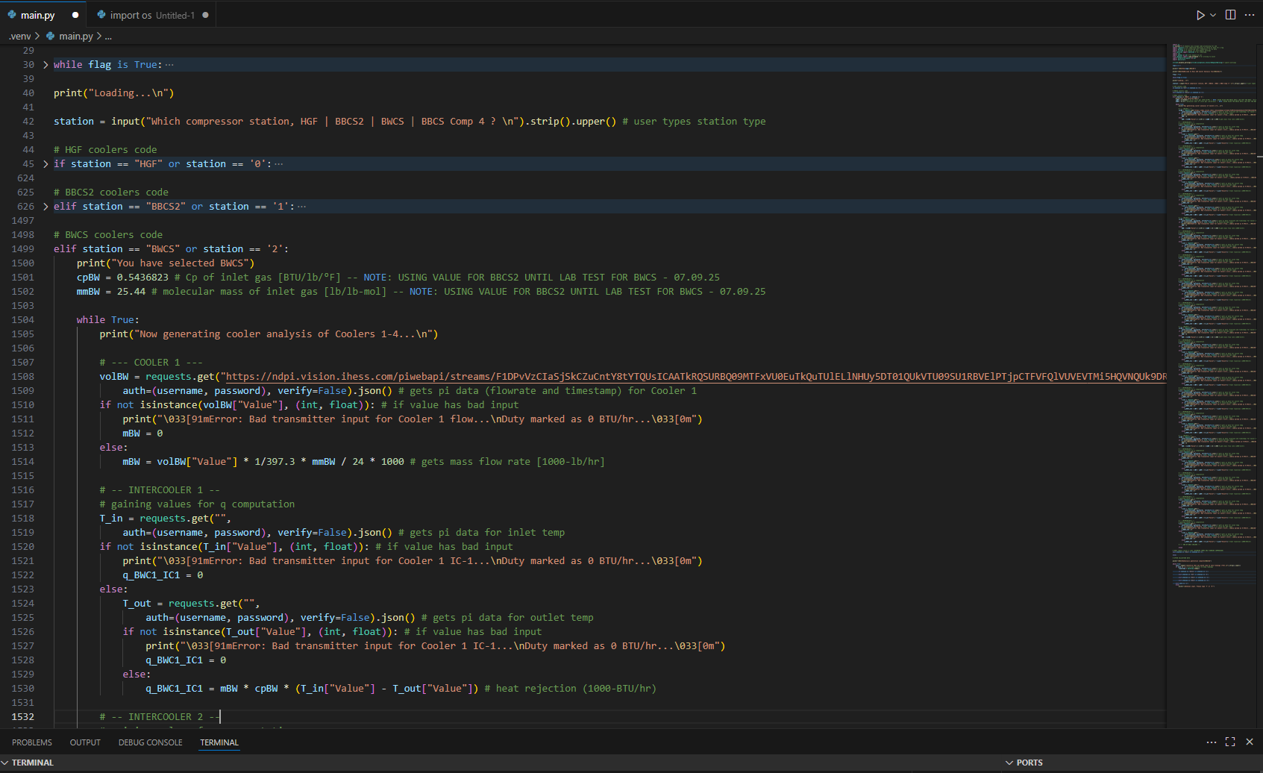
- Repeat for all remaining inlet and outlet temps (currently, 2 per stage, 4 stages per cooler, 4 coolers for the station)
- Then, use the line ‘pyinstaller --onefile main.py’ in order to package the app. It will be found in a folder labeled ‘dist’:
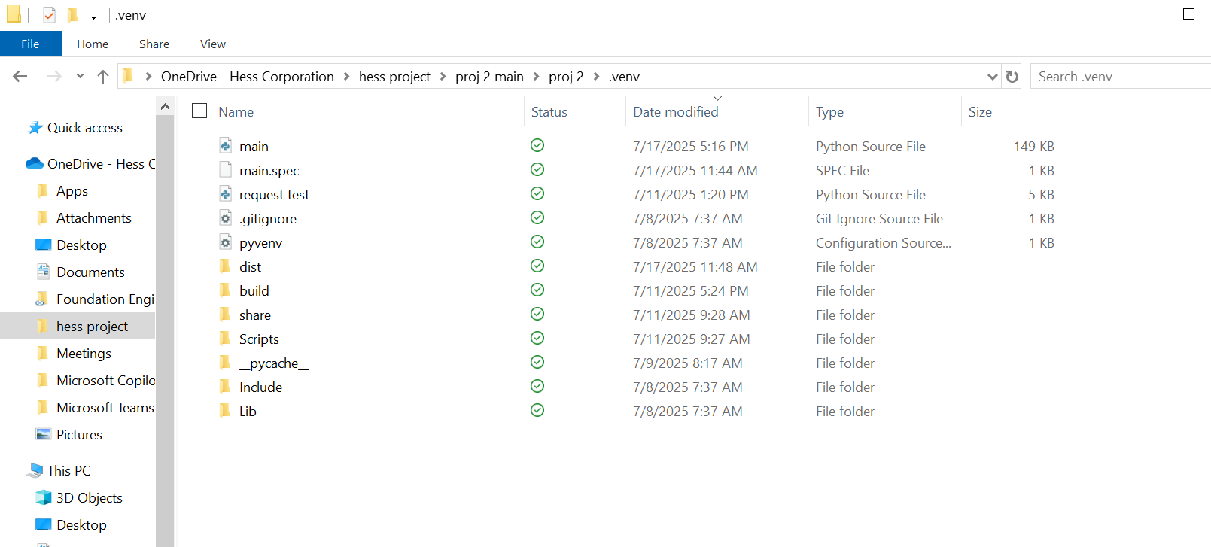
- Finally, move the .exe file to ensure it is housed within the folder with all of the cooler excel workbooks. It will be titled ‘main.py’. Feel free to rename the file as desired. The updated tool will continue to integrate the existing data

- (If new coolers are added) An additional change must be made if new coolers are brought on: the excel workbook needs to be expanded in order to communicate with the program. A new column must be added to the first sheet in the workbook (even if it is a previous run—just substitute 0 for all the values). If an additional stage of cooling is added instead (such as EJW or TAW), a new row must be added.
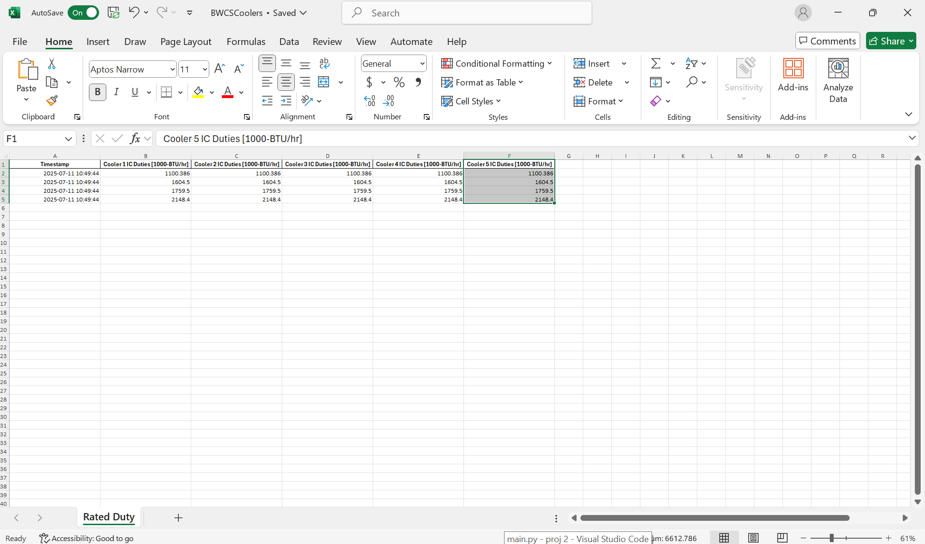
- (If new coolers are added) Next, the program must be updated in its visualization procedures to include the newly added data. First, duplicate the segments of the main loop that look like this, changing the end variable:
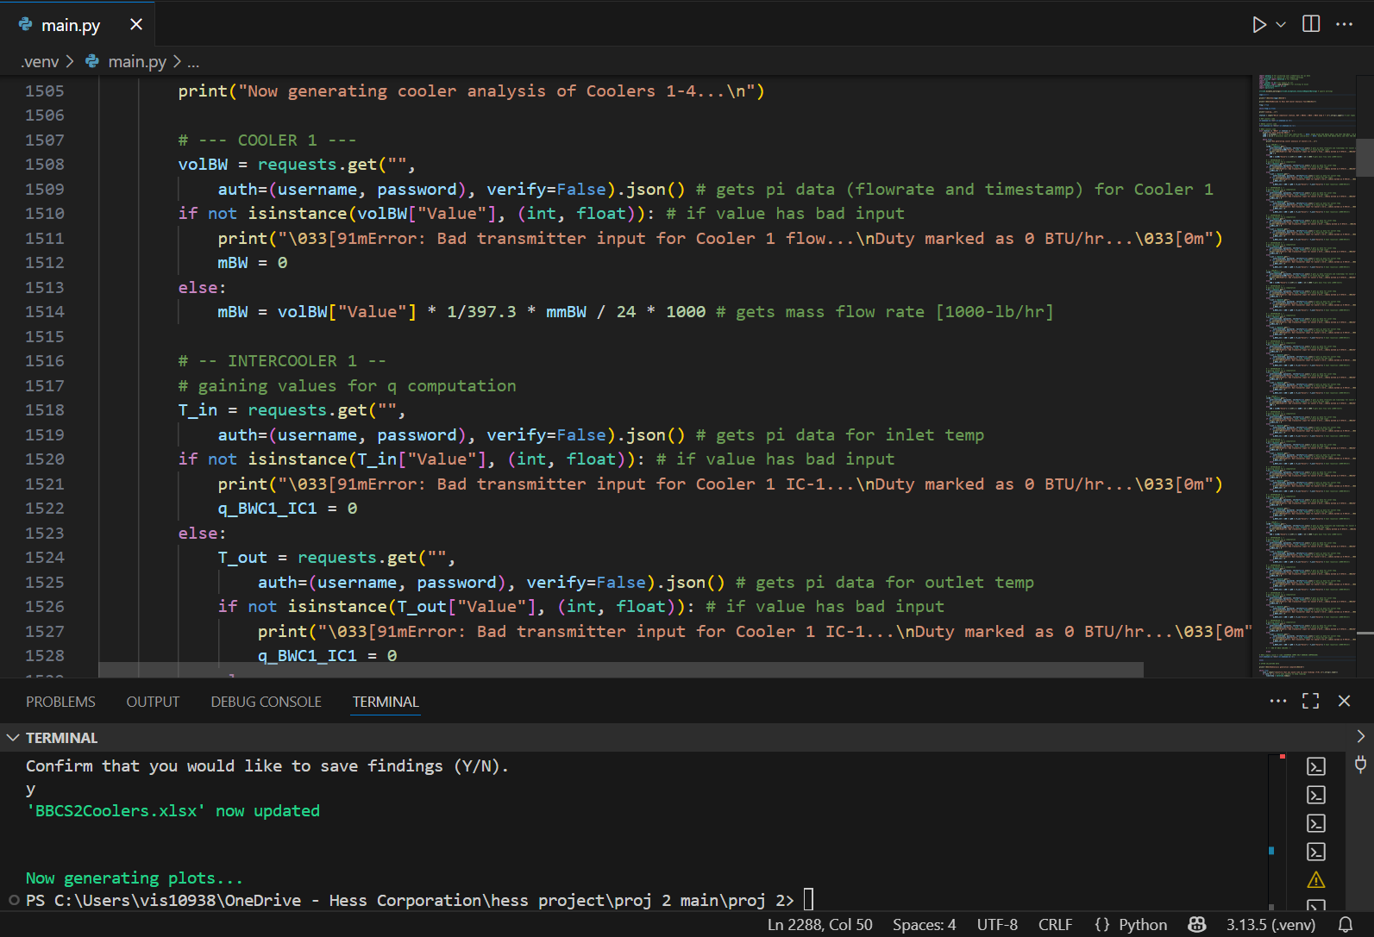
In the case of a 5th cooler to BWCS, once we copy and paste this template code at the bottom of the BWCS section, the variable must be changed to ‘q_BWC5_IC1,’ indicating the duty for 1st stage of cooler 5. This is repeated for stages 2-4 (and so on).
- (If new coolers are added) Once the main code is updated, go to the section labeled ‘BWCS plotting.’ Here, the new variable(s) must be added to the data frame:
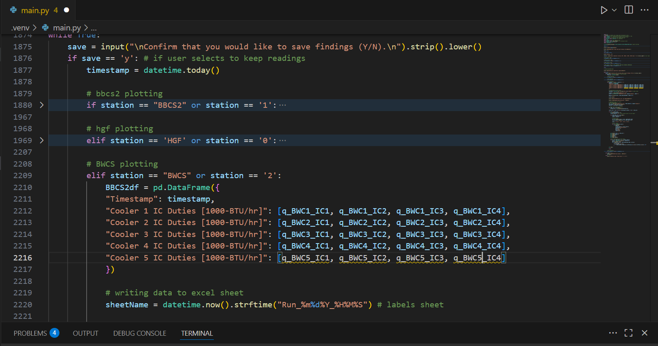
(Alternate Case): Rather than adding a new cooler, if a new stage of cooling not listed (e.g. TAW) is to be added, a few more steps in this section will be necessary to be taken:
- (Alternate Case) Perform the previous step but in a different manner (for adding another stage of cooling to pre-existing coolers):
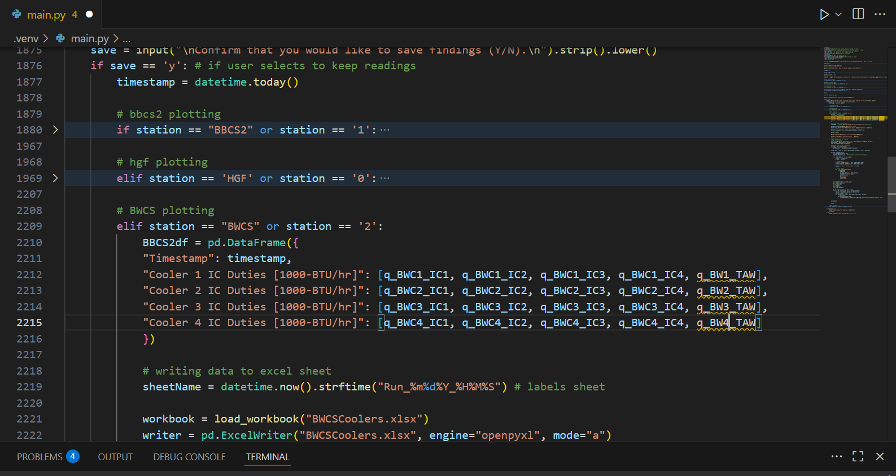
- (Alternate Case) Add a data label tag in the ‘labels’ variable:
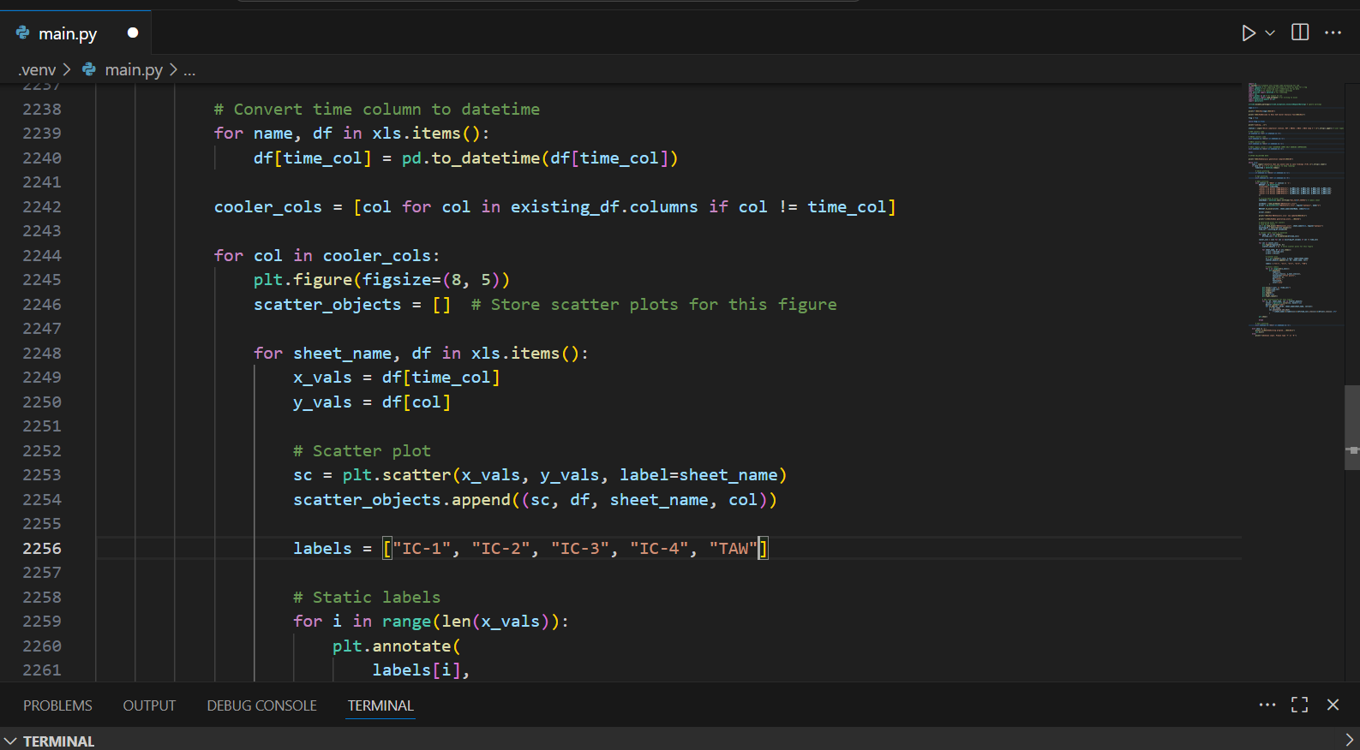
And you are done. The plots will update with an added data point for the extra value(s).

